A project that saved the lives of thousands
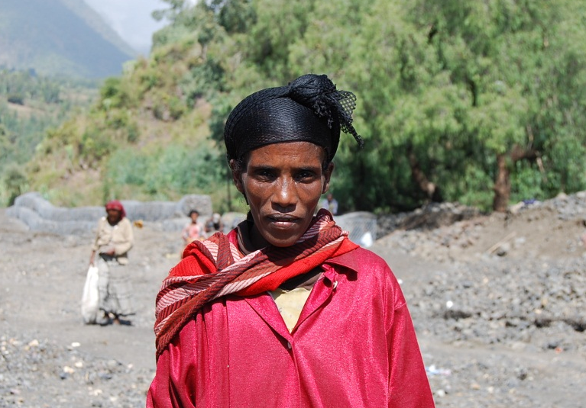
Addis Ababa, 25 January 2013 - When the 2010 flood attacked residents of Wurgessa kebele in North Wello zone of Amhara region in Ethiopia, Mrs. Zebiba Aragaw and her two kids were sleeping. They woke up only when the flood took their house and property.
“All I have was taken by the flood,” Zebiba told FAO. “All our neighbors also lost their yield, property and some of them were even taken by the flood.”
Mrs. Zebiba Aragaw, project beneficiary
“I got life itself from this project,”
The flood that hit the region in 2010 has displaced over 600,000 people, swept away cattle, deteriorated the livelihood of the people, and exacerbated water-borne diseases like AWD and Malaria. Studies by FAO indicated that this was the result of poor watershed management practices, soil erosion, deforestation and improper land use practices.
FAO, with the financial support from the Humanitarian Response Fund (HRF) and in collaboration with Amhara national regional state, implemented a flood mitigation project aimed at reducing the negative impacts of these floods and the risk of displacement of 87,500 people, improving access to 4000ha of crop land and 1500ha of pasture for livestock production and increasing the capacity of community members and wereda extension staff to be able to address flood-related disasters through improved monitoring and management of floods.
Mrs. Zebiba is now a widow with two children. The flood left her bare handed and was only selling kollo [toasted barley] on the street to feed her children.
Mrs. Zebiba and other flood-affected communities of Wurgessa kebele have benefited not only from the flood mitigation work but also generated income for other activities.
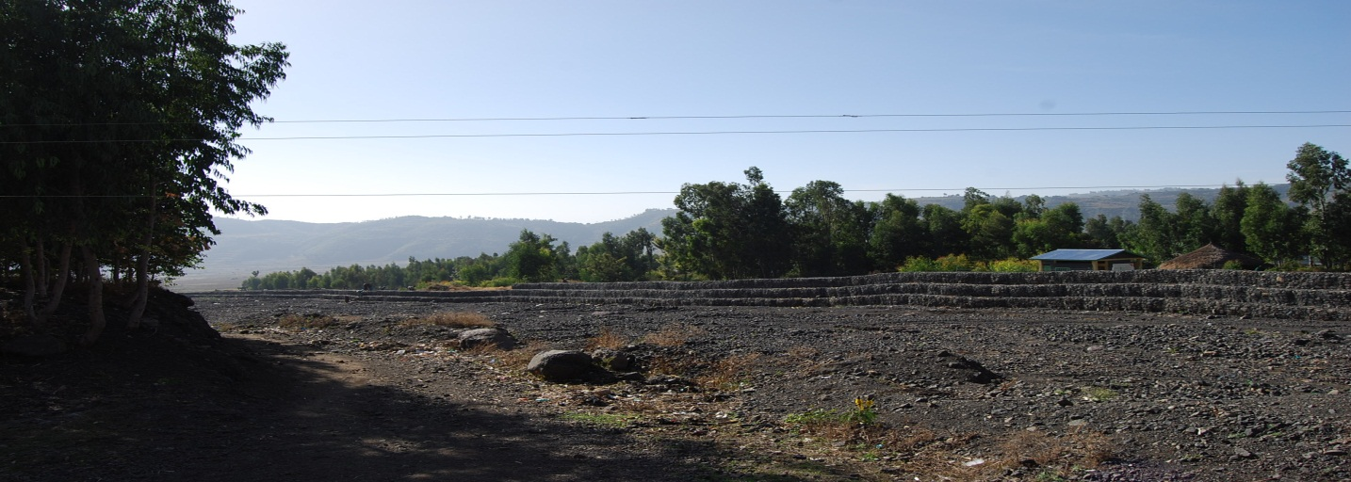
“Without this project and the will of the creator, I would not have been alive by now,” said Mrs. Zebiba, who is currently working as daily laborer at Wurgessa Gabion construction site.
“This project has transformed me. It has changed me a lot. I have started to send my children to school. I have also bought mobile phone, tape recorder and a metal bed. I have also saved 1500birr at the women’s saving group. I am happy and enjoying life than ever before,” she said.
Gabions that have saved the lives of the residents of Wurgessa Kebele, North Wollo Zone, Amhara Region
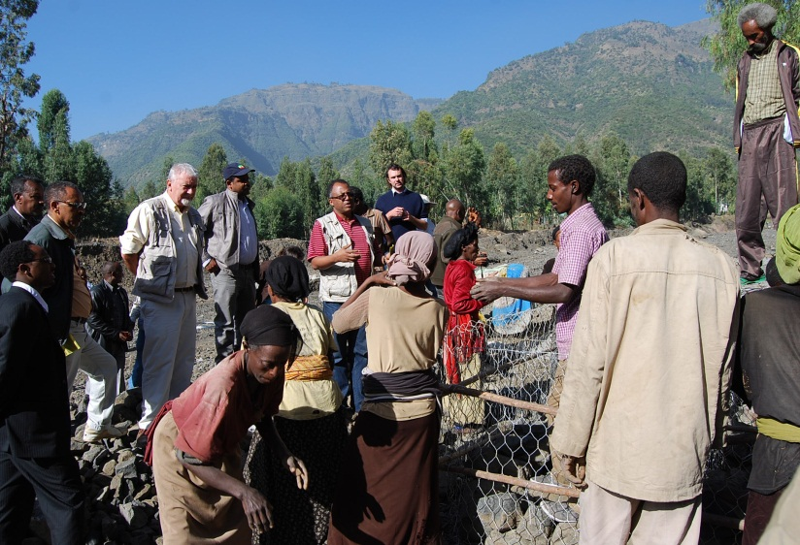
Now, thanks your support and the almighty, I and my neighbors’ are sleeping freely without worrying about flood. I value this more than the money I earn by working on the project. I am now living like a human being! I am really happy,” she told the high level mission who visited the projects in January 2013.
The high level mission from UNOCHA and FAO led by the head of office of UNOCHA Mr. Mike McDonagh and Assistant FAO representative to Ethiopia Mr. Hassen Ali spent two days visiting these projects in Amhara Region. The mission also included the head of disaster reduction management and food security bureau of Amhara national regional state Mr. Sileshi Temesgen.
The high level mission discussing with beneficiaries in Wurgessa flood mitigation site
After visiting the implementation of the project, Mr. Mike McDonagh said that he was impressed to see the achievements of the project. He appreciated the community, FAO and government officials at all levels for the effective implementation of the project.
“I really appreciate your work. You make me think about more Gabions,” he told beneficiaries of the project. “I have no doubt that we will replicate this. It is a very good example for us,” Mr. Mike McDonagh said.
He also said that there is a paramount need to sustaining such life-saving project.
Government representatives for their part also reiterated that the project has transformed the lives and livelihoods of the residents of the flood-affected communities.
They noted the Gabions constructed in the kebele have saved people from being affected by flood and have also helped them to cultivate crops without fear of flood.
The capacity building trainings given at different levels have also strengthened their organizational preparedness and response capacity to mitigate flood and related hazards. They also underscored that the livelihoods of the beneficiaries is also maximized due to sustainable crop and livestock production.
“We are happy with FAO’s assistance and dedications,” said a government representative in Wurgessa Kebele.
For details about this project, please contact the Natural Resources Team Leader, Mr. Abubeker Ali via Abubeker.Ali@fao.org

