FAO, CGIAR to renew partnerships to boost impact on Agriculture, Food and Nutrition Security
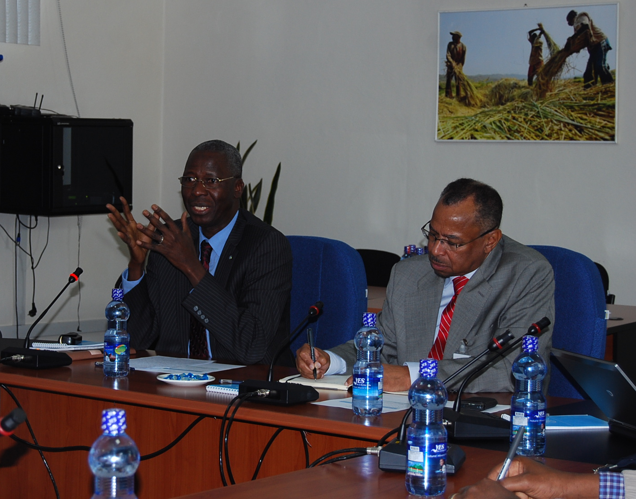Mr. Modibo Traore (left) addressing participants on the importance of partnership between FAO and CGIAR
Addis Ababa, April 05, 2013 – FAO held multi-lateral discussion with the Consortium of International Agriculture Research Centers (CGIAR Consortium) based in Ethiopia to form a strategic partnership to boost the impact of its activities.
The meeting was held at FAO Ethiopia conference hall in Addis Ababa and was aimed at ensuring effective evidence and knowledge based information sharing between FAO and the research centers.
At global level, the Food and Agriculture Organization of the United Nations and the Consortium of International Agriculture Research Centers have signed a Memorandum of Understanding in February 2013 to engage in a strategic partnership, building on the institutional strengths of both organizations, in order to increase the effectiveness and impact of their work.
The MoU was signed by FAO Director-General José Graziano da Silva and Carlos Pérez Del Castillo, CGIAR Consortium Board Chair in February 2013.
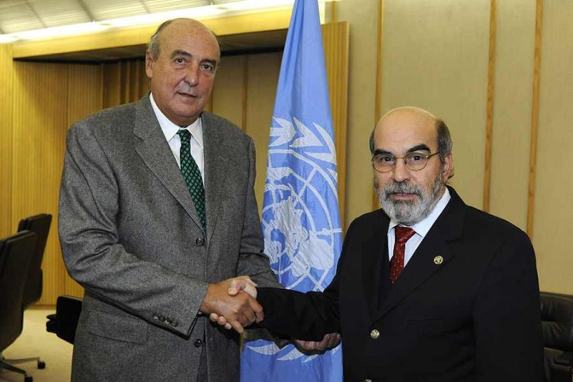
According to the MoU the partnership will boost the ability of both organizations to scale up their efforts and make a powerful, joint contribution to the world's food security needs.
It is based on this global partnership that FAO Sub regional office for Eastern Africa and representation to Ethiopia, AU and the ECA office and the CGIAR based in Addis Ababa met and discussed on renewing their partnership at country, regional and continental level.
Carlos Pérez del Castillo (left) with José Graziano da Silva (right) after signing the Memorandum of Understanding in February 2013
Opening the discussion forum, FAO Sub regional coordinator for Eastern Africa and representative to Ethiopia, AU and ECA, Mr. Modibo Traore said coordination and partnership between FAO and CGIAR will have a paramount importance in supporting and materializing the global agreement between FAO and CGIAR.
"An important partnership between FAO and the CGIAR Consortium research centers has been reached at global level. Our coordination at the field level will have an important contribution to make to eradicating hunger, producing and managing resources sustainably, reducing rural poverty, improving participation of smallholders in food systems, increasing resilience in rural communities and nutrition security," Mr. Traore said.
“Working together will make our work more reliable, scientific and evidence based,” he added.
Director General of the International Livestock Research Institute (ILRI), Dr. Iain Wright for his part said that working with FAO will enable ILRI and the CG centers bring strategic development results and impacts at different levels.
“We would like to influence government on key strategic issues, and working with FAO will therefore enable us to better influence the government and its partners,” he added.
Other CG centers, including CIMMYT, IFPRI, Biodiversity international, ICRAF, ICARDA, CIFOR, CIP and IWMI also reiterated that working with FAO on key strategic issues will help them to critically evaluate the effectiveness of their research endeavors in development interventions at grassroots level.
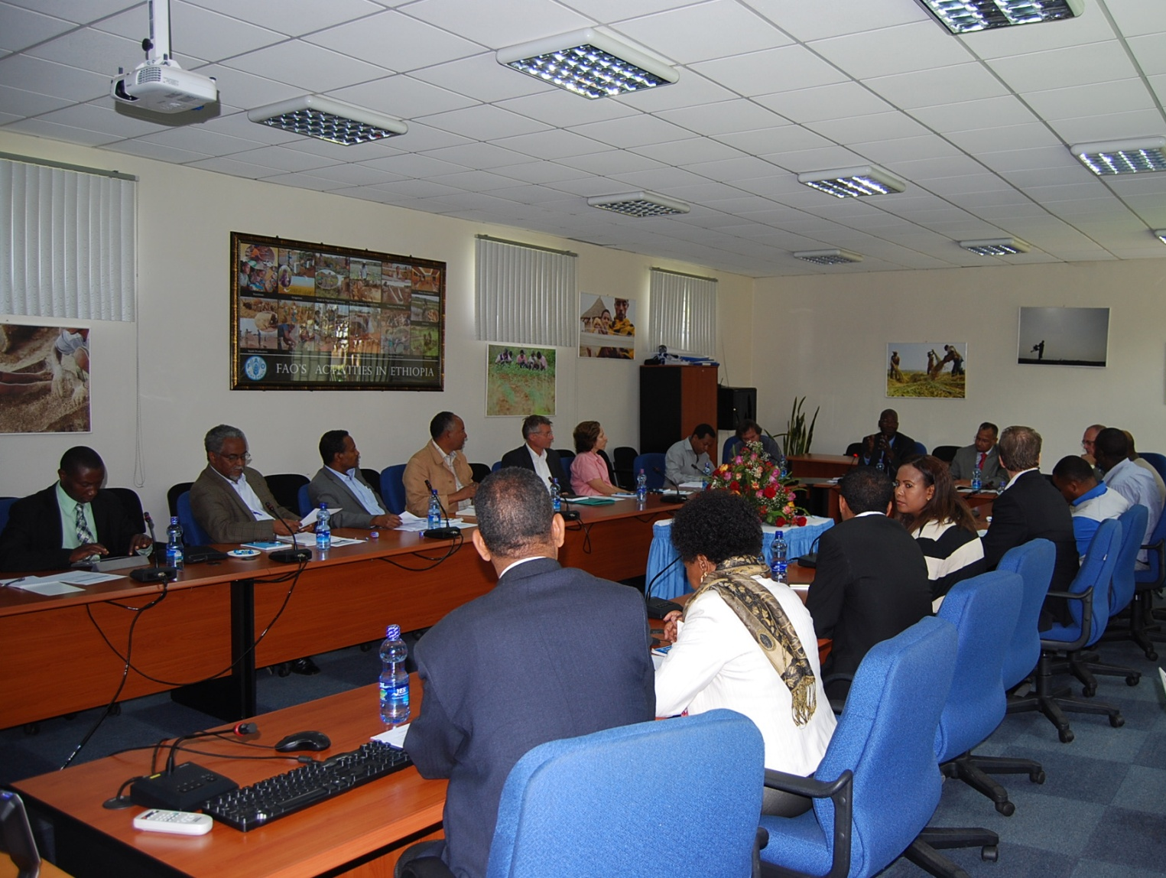
The half-day meeting between FAO and CGIAR also created a platform to introduce each other’s strategic focus areas, interventions and partnerships which helped the leadership to identify areas of collaboration and partnership.
Participants of the meeting in Addis Ababa, Ethiopia
According to the presentation by FAO’s Multi-Disciplinary Team and representatives of the respective CG centers, partnership and collaboration in market development, capacity building/development, knowledge management and dissemination on food and nutrition security, regional flagship program, PPR vaccination, sustainable intensification of crop production, consumption of food and sustainability will bring more impact and efficiency to both sides.
Besides these, working together on policy issues including access to decision makers and the creation of Ethiopian Development Forum will also help to raise levels of nutrition, improve agricultural productivity, better the lives of rural populations and contribute to the growth of the Ethiopian economy.
Accordingly, a Technical Task Force (TTF) drawn from FAO, ILRI, IWMI and IFPRI chaired by Dr. Iain Wright has been mandated by the organizations to further investigate areas of collaboration and partnership between the organizations.
The Global framework
Under the renewable, five-year agreement, FAO will provide the CGIAR Consortium with advice on priorities for agricultural research based on FAO's work for member governments, as well as information on priority programmes or activities FAO is implementing.
The CGIAR Consortium will advise FAO on the potential for scaling up innovation in agriculture and updated information on CGIAR Research Programs.
One particular area of cooperation with FAO will involve making new technologies developed by CGIAR and others available to small-scale farmers.
The CGIAR Consortium is an international organization made up of 15 Centres engaged in research for a food-secure future, whose main role is to oversee the implementation of the CGIAR's Strategy and Results Framework, including the CGIAR Research Programmes.
The Consortium, together with its financing arm, the CGIAR Fund, was established in 2010 in a reform of the Consultative Group on International Agricultural Research, a worldwide network of agricultural research centers created four decades earlier.
CGIAR research is dedicated to reducing rural poverty, increasing food security, improving human health and nutrition, and ensuring more sustainable management of natural resources. It is carried out in close collaboration with hundreds of partner organizations, including national and regional research institutes, civil society organizations, academia, and the private sector.
FAO's mandate is to raise levels of nutrition, improve agricultural productivity, better the lives of rural populations and contribute to the growth of the world economy. Eradicating hunger and achieving food security for all is at the heart of FAO's efforts - to make sure people have regular access to enough high-quality food to lead active, healthy lives.
For more information on this, please email Mrs. Susan Minae, susan.minae@fao.org

