FAO, AU SIGN A MEMORANDUM OF UNDERSTANDING to Address the implications of avian influenza A H7N9
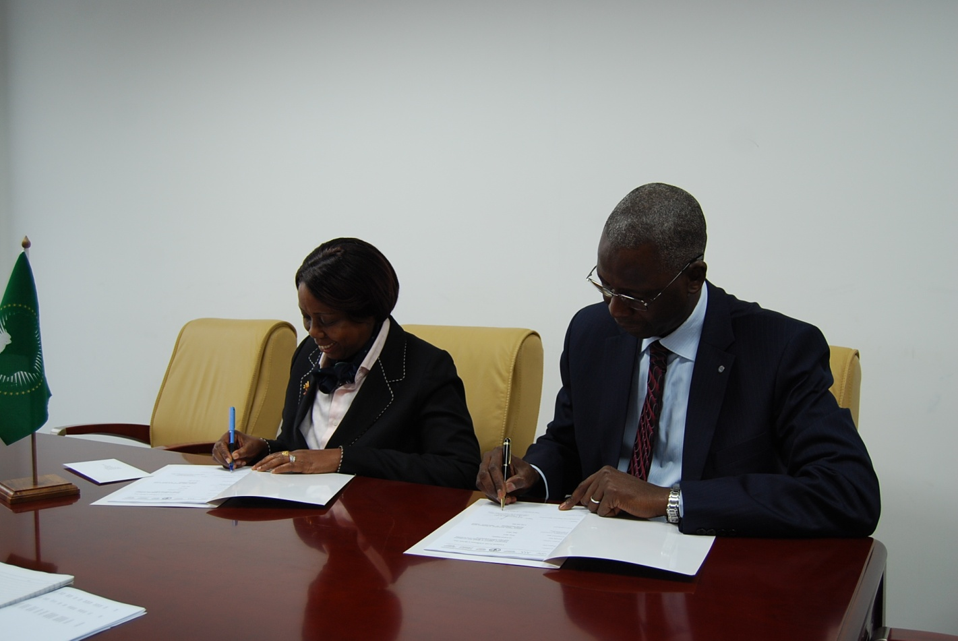H.E. Tumusiime Rhoda Peace, Commissioner for Rural Economy and Agriculture of the African Union[left] and H.E Dr. Modibo Traore, FAO Representative to the African Union, UNECA, Ethiopia and Sub-Regional Coordinator for Eastern Africa[Right]signing the MoU at the Headquarters of the African Union.

ADDIS ABABA, Ethiopia, August 06. 2013 – The Food and Agriculture Organization of the United Nations and African Union Commission (AUC) signed a Memorandum of Understanding for the prevention and control of potential outbreaks of influenza A (H7N9)

The signing ceremony was held in the presence of Her Excellency Tumusiime Rhoda Peace, Commissioner for Rural Economy and Agriculture at the AUC and Dr. Modibo Traore, FAO Representative to the African Union (AU) and to the UN Economic Commission for Africa (ECA), Subregional Coordinator for Eastern Africa and FAO Representative in Ethiopia , who signed the agreement on behalf of their respective organizations.

During the signing ceremony both institutions agreed, under the project “Emergency support to global and coordinated response to influenza A (H7N9) virus in poultry and other animal populations”, to step up their collaboration in preventing, controlling and mitigating the potentially harming socio-economic consequences on poultry population, human health and livelihoods of an influenza A (H7N9) outbreaks on the continent.

Dr. Modibo Traore specified that the in built technical support component of the project will provide additional capacity to the AU in preventing and mitigating this growing threat. It furthermore contribute to the implementation of Emergency support and coordinated response mechanisms to influenza A (H7N9) virus at continental level, ultimately preventing the virus to spread in Africa.

In the name of the African Union and its member countries, H.E. Tumusiime expressed the gratitude of the AUC regarding the support granted by the United Nations FAO under the Technical Cooperation Programme (TCP) just signed.

“The FAO-AU joint collaboration shares a common vision of working together to make a difference in the lives of the people. Within the framework of this new intervention, we shall be working closely with FAO,” Commissioner Tumusiime said after signing the MoU.

About the project
The project as a whole will contribute to minimizing the impact of H7N9 on poultry population, human health and livelihoods Africa. It also aims to ensure, through a global cohesive and coordinated response framework, that affected and at-risk countries have improved capacity to detect early and respond rapidly to new infection of influenza virus A (H7N9).

Through this TCP, FAO’s support will strengthen the national capacities for quick response to the new influenza A (H7N9) crisis. It will, among others, help develop the capacities of international and regional organizations as well as other agencies and national governments.
The project will also foster partnerships and alliances among key stakeholders by fostering linkages with other initiatives in the affected regions to further improve disease control mechanisms.

Furthermore, the project will play a catalytic role in filling the funding gap by attracting additional donors’ contributions to enhance countries capacity to face the H7N9 crisis.

H7N9, a serotype of the species Influenza virus A was first reported to have infected humans in February 2013 in China. The priority activities, under this TCP, will be to target at-risk countries including those previously infested with bird flu (HPAI), notably Egypt, Nigeria, Ghana, Cote D'Ivoire and Cameroon and those having close trade ties and flight connections with China particularly, Kenya, Zambia, DRC, Tanzania, Ethiopia and Senegal.

Since the outbreak of the panzootic H5N1 HPAI, FAO established ECTAD to coordinate and deliver FAO’s support to member countries in their efforts to respond to trans-boundary animal health crises at the sub-regional level, and to support disease control efforts in infected countries and preparedness activities in other parts of the world.

About the H7N9 Influenza
H7N9 is a new subtype of avian influenza virus. The current H7N9 virus is a reassortant (i.e. mix) of viruses previously detected in wild birds and poultry. The recent event in China represents the first ever report of H7N9 virus affecting humans. According to WHO, patients with this infection have had severe pneumonia. Symptoms include fever, cough and shortness of breath. However, information is still limited about the full spectrum of clinical signs due to infection with the H7N9 virus.

FAO is therefore monitoring the situation closely through its wide network of country offices, reference centres and other partners including the World Health Organization (WHO) and the World Organisation for Animal Health (OIE).

FAO and the scientific community are currently studying the virus sequences in order to better understand its properties and deliver diagnostic capable of detecting this new strain of influenza virus.

FAO has set up a website for H7N9 and has posted guidelines for surveillance, risk assessment and risk management for avian influenza A(H7N9) for affected and at risk countries.
***

